­­­­­

|  |  |
| --- | --- |
|  |  |



Final Project - Team 3

**Solution Design   
Document**



Table of Contents

I. Purpose 3

II. Document History 4

III. Automated process details 5

2 Runtime guide 6

2.1 Architectural structure of the Master Project 6

2.2 Master Project Runtime Details 7

2.3 Project(s) workflows 8

2.4 Packages 8

2.5 Architectural structure of the Master Project 8

Other Details 9

Future Improvements 9

Other Remarks 9

Glossary 10

# Purpose



Outlines the major components of the Master Project (the overall output of the development, containing one or multiple projects that together cover the scope of the robotic process automation) taking into account all the business restrictions (scheduling, peaks, future increases in volume etc.). The focus of the Solution Architect will be on:

* Robustness;
* Scalability;
* Efficiency;
* Replicability;
* Reusability of component

The information herein is targeted primarily at the developers that will initially implement the solution and subsequently at the support developers in case of change requests.

# Document History

|  |  |  |  |  |  |  |
| --- | --- | --- | --- | --- | --- | --- |
| Date | Version | Role | Name | Organization/ Department | Function | Comments |
|  | 1.0 | Author |  |  | Developer | Initial Draft |
|  |  |  |  |  |  |  |
|  |  |  |  |  |  |  |
|  |  |  |  |  |  |  |
|  |  |  |  |  |  |  |

# Automated process details

Details filled in need to reflect the actual information for the Master Project released for production. The following table will be populated:

|  |  |
| --- | --- |
| Item | Description |
| Project Name | FinalProjectTeam3 |
| Robot Type | Attended |
| Orchestrator used? | Yes |
| Scalable | No |
| UiPath version used | Studio 2022.10 |

# Runtime guide

## Architectural structure of the Master Project

Display the interaction between components (package / robots, Orchestrator queues, and running order) in a diagram

## Master Project Runtime Details

Outlines the details of the automated process by filling in the table below.

|  |  |
| --- | --- |
| ITEM NAME | DESCRIPTION  *Fill in each bolded section - empty fields are not allowed. If the section does not apply to your automation then mark as n/a.* |
| Production environment details | Machine Name: “desktop-gunflp4\toha”  Machine Name:” DESKTOP-TEQUDDP\le” |
| Prerequisites to run | Internet connection, Microsoft Edge installed, Installing the UiPath Extension for Microsoft Edge, Microsoft Excel installed, Microsoft Outlook installed and the mail is signed in, and SMSS Installed with a valid server connection, Asset values and queues are preset |
| Input Data | Mails that contains certain value in the subject and in the body |
| Expected output | Database tables for the invoices details for each vendors/ Database table for the Vendors and processing details/ PDF for each invoice for each vendor/ compressed folder for each vendor containing all of its PDF files/ Sent email to the admin with each compressed folder |
| How to start the automated process | Run the Dispatcher Main.xaml file |
| How is Orchestrator used? | Queues to save the data like the vendors list and the invoices list each on separate queues/ Assets to save credentials and to save the contact Mail addresses |
| Password policies (mention any specific compliance requests) | Acme Credentials |
|  |  |
|  |  |
| List of queues names | ACME_Vendors and ACME_Invoices |
| Schedule Details | N/A |
| Multiple Resolutions Supported?  (in case of image automation / Citrix and VDI) | NO |
| Recommended Resolution | N/A |
| Scalable | ***Yes*** |
| Environment used for development  (name, location, configuration details etc) | N/A |
| Environment prerequisites  (OS details, libraries, required apps) | Windows 10, SQL Server Management Studio, Microsoft Excel, Microsoft outlook, edge, necessary add ins for uipath in edge installed |
| Repository for project  (where is the developed project stored) | Locally |
| Configuration method  (assets, excel file, Json file) | Excel file |
| List of reused components | Acme_Login Workflow |
|

## Project(s) workflows

For the workflow files defined below please specify the input and output parameters.

|  |  |  |
| --- | --- | --- |
| Workflow file | Arguments | Description |
| Performer | | |
| Main | in_OrchestratorQueueName  in_OrchestratorQueueFolder |  |
| ACME_ScrapInvoices | In_TaxID  Out_Invoices  in_config  In_Sender |  |
| AddToDatabase | in_config  In_vendor  in_DT_Invoices |  |
| UploadQueueItems | in_config  in_DT_Invoices |  |
| GetTransactionItems(INVOICES) | in_VendorsTransactionItem  in_config  in_VendorName  in_TaxID  in_Address  in_City  in_Country |  |
| ACME_Close | in_config |  |
| ACME_Login | in_config |  |
| CloseAllApplications | in_config |  |
| Count Items | in_Config |  |
| DatabaseUpdate | In_vendor  In_Status  In_StartTime |  |
| GetTransactionData | in_TransactionNumber  in_Config  out_TransactionItem  out_TransactionField1  out_TransactionField2  out_TransactionID  io_dt_TransactionData  out_VendorName  out_TaxID  out_Address  out_City  out_Country |  |
| InitAllApplications | in_Config |  |
| InitAllSettings | in_ConfigFile  in_ConfigSheets  out_Config |  |
| KillAllProcesses | in_config |  |
| Process | in_TransactionItem  in_Config  In_MailMsgs  in_VendorName  in_TaxID  in_Address  in_City  in_Country |  |
| RetryCurrentTransaction | in_Config  io_RetryNumber  io_TransactionNumber  in_SystemException  in_QueueRetry |  |
| SetTransactionStatus | in_BusinessException  in_TransactionField1  in_TransactionField2  in_TransactionID  in_SystemException  in_Config  in_TransactionItem  io_RetryNumber  io_TransactionNumber  io_ConsecutiveSystemExceptions |  |
| TakeScreenshot | in_Folder  io_FilePath |  |
| Update with exception | In_Vendor  In_Msg  In_EndTime |  |
| Outlook_GetMailMessages | in_subject  Out_MailMsgs  in_config |  |
| Outlook_Response | In_config  Out_Reply  In_MailMsgs  in_sender  in_TransactionItem  In_Vendor |  |
| GetTransactionDataTestCase |  |  |
| InitAllApplicationsTestCase |  |  |
| InitAllSettingsTestCase |  |  |
| MainTestCase |  |  |
| ProcessTestCase |  |  |
| WorkflowTestCaseTemplate |  |  |
| Dispatcher | | |
| Main | in_OrchestratorQueueName  in_OrchestratorQueueFolder |  |
| ACME_ClickResetData | in_config |  |
| ACME_Close | in_config |  |
| ACME_Login | in_config |  |
| ACME_ResetData | in_config |  |
| ACME_Vendors | in_config  Out_DT_Vendors |  |
| AddToDatabase | in_config  in_DT_Vendors |  |
| CloseAllApplications | in_config |  |
| GetTransactionData | in_TransactionNumber  in_Config  out_TransactionItem  out_TransactionField1  out_TransactionField2  out_TransactionID  io_dt_TransactionData |  |
| InitAllApplications | in_Config |  |
| InitAllSettings | in_ConfigFile  in_ConfigSheets  out_Config |  |
| KillAllProcesses | in_config |  |
| Process | in_TransactionItem  in_Config |  |
| RetryCurrentTransaction | in_Config  io_RetryNumber  io_TransactionNumber  in_SystemException  in_QueueRetry |  |
| SetTransactionStatus | in_BusinessException  in_TransactionField1  in_TransactionField2  in_TransactionID  in_SystemException  in_Config  in_TransactionItem  io_RetryNumber  io_TransactionNumber  io_ConsecutiveSystemExceptions |  |
| TakeScreenshot | in_Folder  io_FilePath |  |
| UploadQueueItems | in_config  in_DT_Vendors |  |
| GetTransactionDataTestCase |  |  |
| InitAllApplicationsTestCase |  |  |
| InitAllSettingsTestCase |  |  |
| MainTestCase |  |  |
| ProcessTestCase |  |  |
| WorkflowTestCaseTemplate |  |  |

# Other Details

### Future Improvements

Fill in any improvements that need to be considered for the future:

*• Optimize the processing algorithm*

*• Enhance the execution time*

# Glossary

The main terms used in the Solution Architecture Document are defined below:

**Master project** - the overall output of the development, containing one or multiple projects that together cover the scope of the robotic process automation. There is a 1 to 1 connection between the Master Project and the Process to be automated (As presented in the PDD).

**Project** - an UiPath Studio project containing one or multiple workflow files. A project can be converted to a package and run independently, covering a particular scope within the master project. Or multiple projects can be converted into one package depending on the aims and restrictions of the automation. The project is used when defining the development and support phase of the automation.

**Package** - the output of compiling one or multiple projects. A package can be deployed on the robot machine and be executed by the robot service. Only one package can be executed at a given time by a robot. The package is used when defining the running phase of the automation.

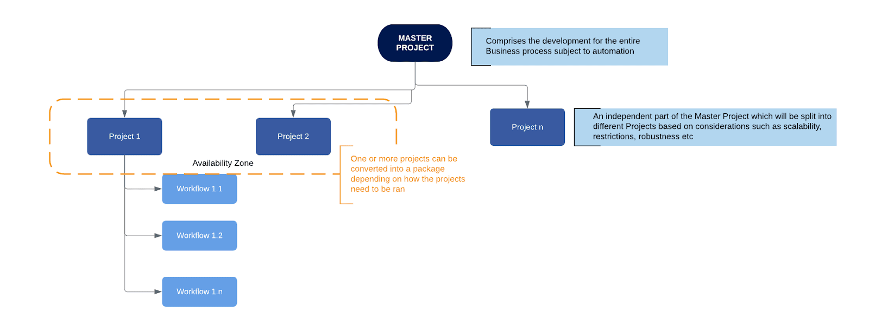Workflow - a component of the package, the workflow encapsulates a part of the project logic. The workflow can be of type: sequence, flowchart or state machine. A workflow is saved as an .xaml file inside the project folder. A workflow file can be invoked from another workflow and by default there is an initial workflow file that will run when executing the package.

**Activity** - an action that the robot executes.

**Sequence** - a workflow where activities are executed one after another, in a sequential order

**Flowchart** - a workflow where activities are connected by arrows and the logic of the workflow can be easily followed in a visual manner. The flowchart can also be exported as an image from UiPath studio.

**State machine** - a more advanced way of organizing a workflow, similar to a flowchart.

**BOR** - Back office robot

**FOR** – Front office robot

**Orchestrator** – Enterprise architecture server platform supporting: release management, centralized logging, reporting, auditing and monitoring tools, remote control, centralized scheduling, queue/robot workload management, assets management.